Describe the objectives of the research.

Low efficiency in massive data query, lack of unified data specification, and short in supporting space-time property of data are serious problems to be solved today. In this project, we need to analyze data with space or time characteristics. And use the result to extracts the needed data pieces from the huge amount of data. At last we use the obtained results for projections, comparison and draw the relevant conclusions.

1. Question1: How to analyze the huge amounts of data the sensors collect?

* Classifying the data according to property characteristic
* Fitting the treated data to correlation function[8]

2. Question2: How to use the data to fit better correlation functions?

* Using the method in data mining:

Handling the data with Bernstein- Bézier curve[9]

* Using the method in machine learning:

Combining supervise learning and unsupervised learning to handle the data

* Storing the underlying data with NoSQL database
* Classifying the data while storage, and add semantic meaning with tags [10]
* Avoiding traversal algorithm
* Using parallel computing [11], [12] to optimize the algorithm

3. Question3: How to search the required data fragments from the big amount of data?

* Using the idea of feature extraction [13] to find pieces of data
* Using the idea of pattern recognition [14] to find pieces of data
* Determining the trend of the data through the correlation function

4. Question4: Where can we use the result we obtained?

* Optimizing data query
* Helpful for the data projection
* Helpful for the data comparison

Innovation and project characteristics:

There are five aspects of innovation in our project:

1. Using parallel computing to improve optimization data query

2. Storing data with classification tag

3. Using the idea of feature extraction and pattern recognition to find pieces of data

Based on objectives of our keystone project, the complete work process is shown in Figure 1.

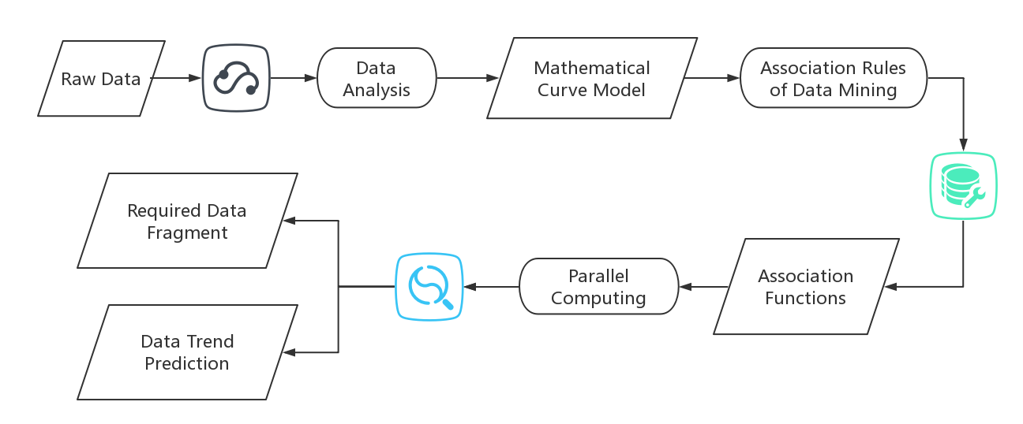

Figure Work Process